**1. INTRODUCTION**

|  |  |
| --- | --- |
| **TEMPERATURE:** Degree of relative coldness and hotness.  Temperature is effect of kinetic energy of molecule present in the substance.  **Kelvin Temperature Scale:** No Negative term in the temperature.  0 K = 0 kinetic energy of molecule.  **Absolute Temperature:** Temperature measured with respect to absolute **zero kelvin** temperature.  **TK = TC + 273.**  **PRESSURE:**  1) Normal Force exerted per unit area.  2) Rate of change of moment per unit area. | Learn Molecules and its arrangement in solids, liquids and gases ... |

**Absolute Pressure:**

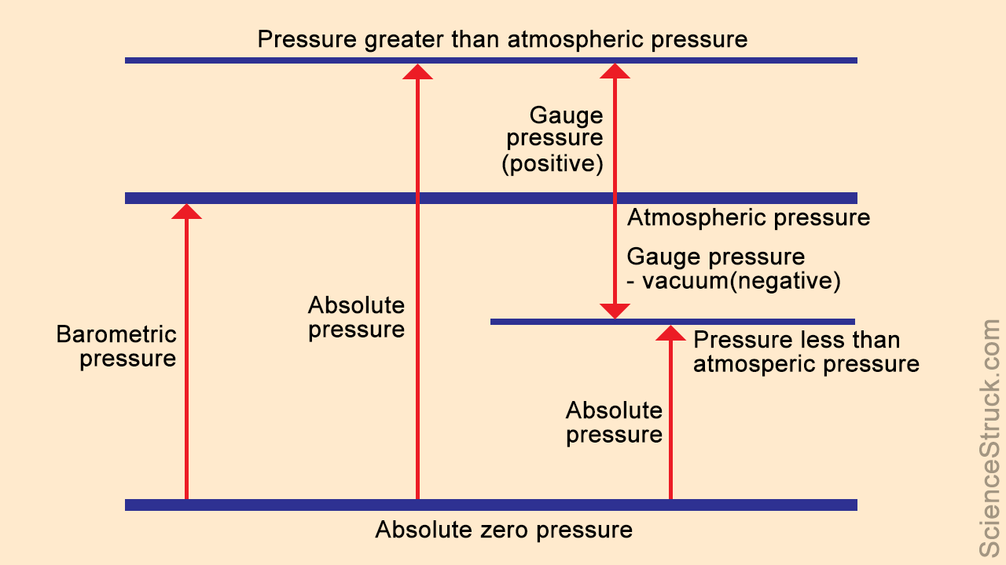

**Physical meaning of volume:**

|  |  |
| --- | --- |
| gas $\underset{→}{∆}$ Molecules move away => volume increase => Velocity increases => Kinetic energy increases | gas $\underset{→}{-∆}$ Molecules come together => volume decrease => Velocity Decreases => Kinetic energy Decreases |

|  |  |
| --- | --- |
| **Macroscopic Approach** | **Microscopic Approach** |
| Average molecules behaviour | Each/individual molecules behaviour |
| Classical Thermodynamics | Statistical Thermodynamics because Large number of equations required to be solved |
| Qty uses: Average P, T, V |  |
| Use in internal combusting engine, RAC, Power Plants | Use in Plasma, Laser, Missiles |

**Continuum Hypothesis: Metter is continuous function of space, time.**

1 m3 => 2.4* 1024 Molecules

**Mean Free Path:** Average distance between molecules.

MFP < Characteristic length (**Continuum concept is valid**)

Highly vacuum condition **/**at high elevations **/**Rarefied Gases **/**MFP > Characteristic length (**Continuum concept is not valid**)

Because elevations **˄** => Pressure **˅** => Density **˅** => Volume **˄** => MFP **˄**